**AWS TUTORIAL FOR INSTALLING OPENVPN TO THE CLOUD.**

It comprises of;

* Setting up a OpenVPN Server.
* Setting up OpenVPN Client in the Local Machine.
* Launch A New Instance (OPENVPN Access server) from AWS Market Place;

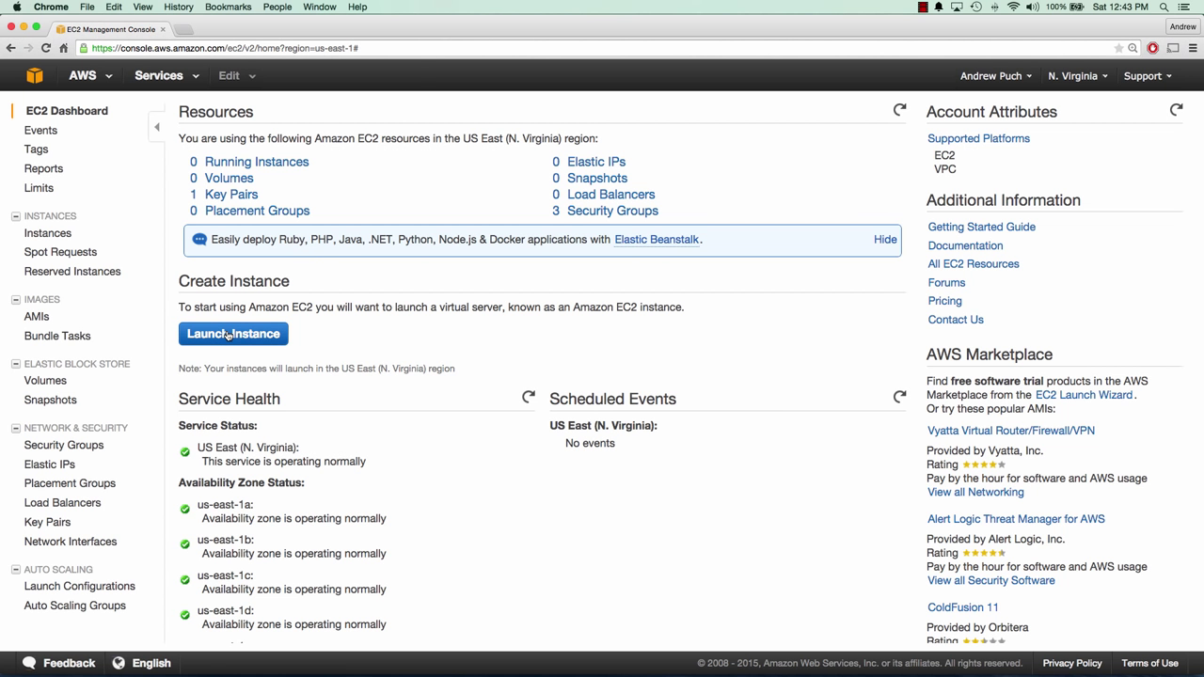

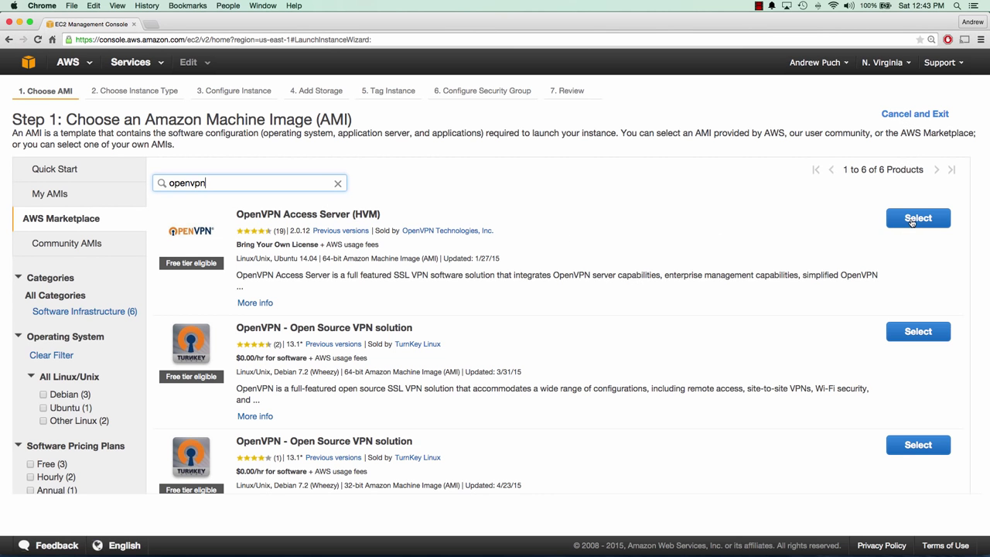

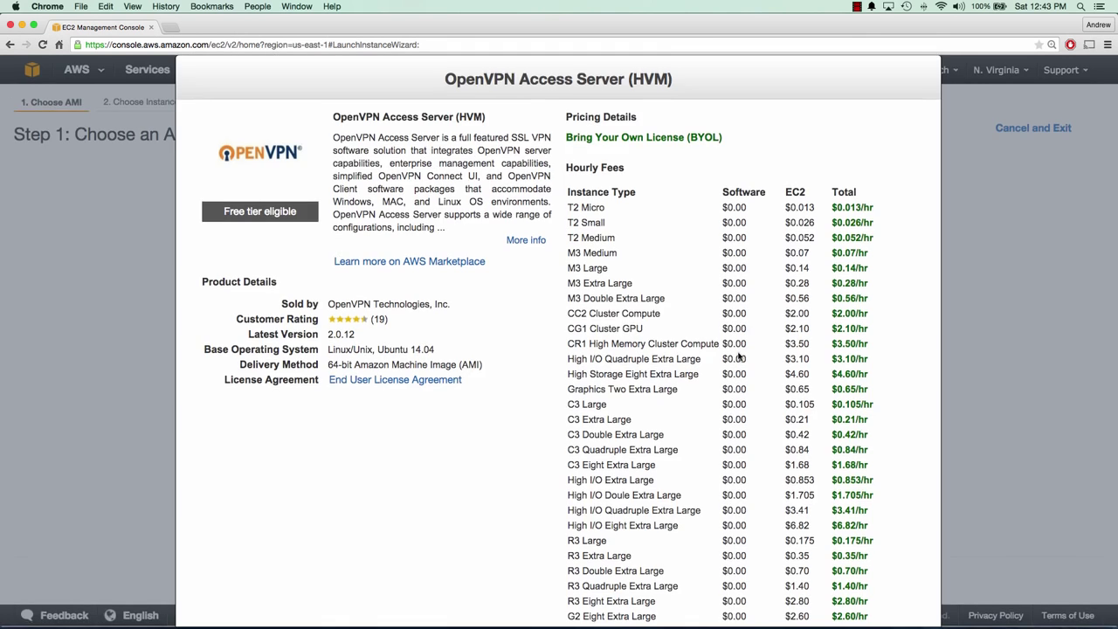

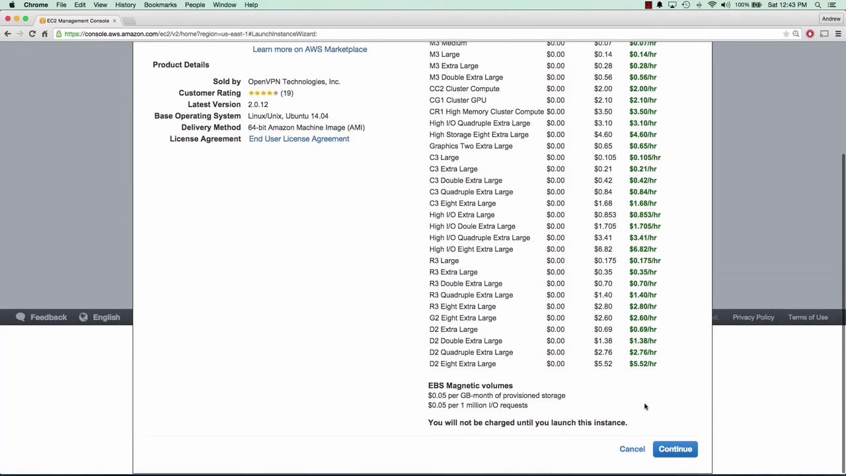

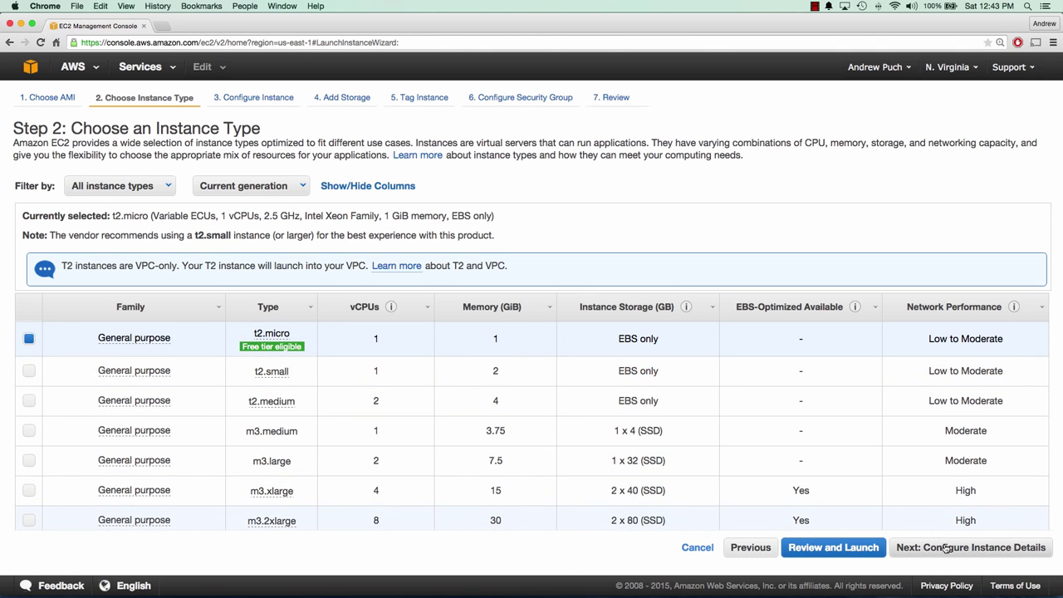

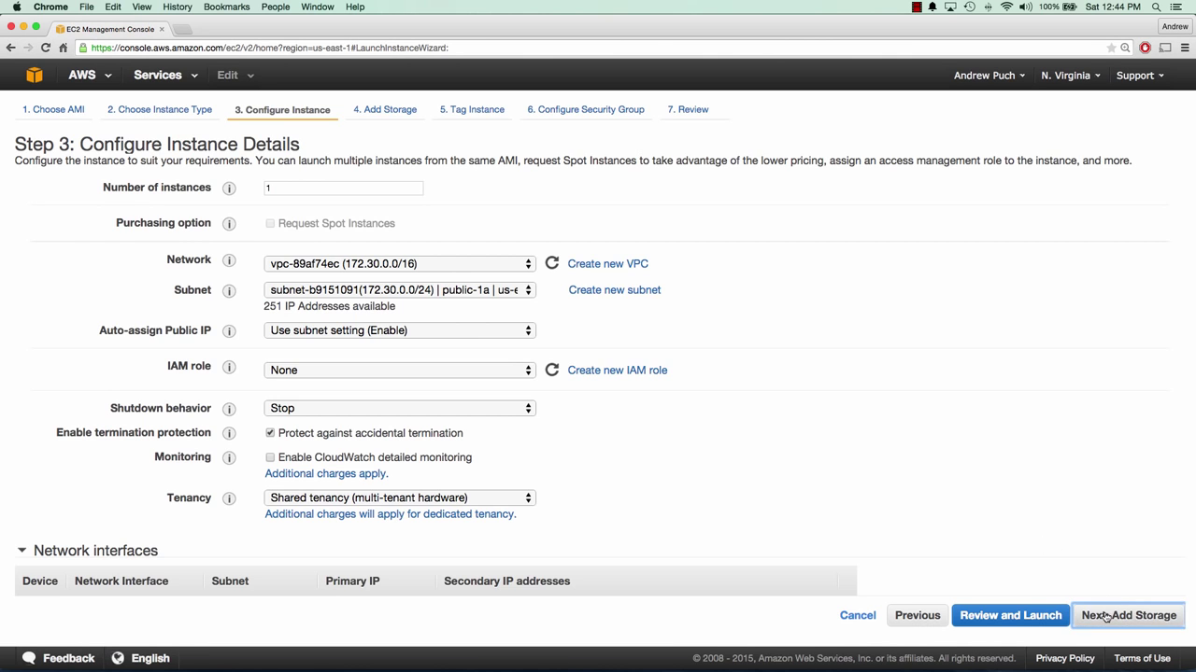

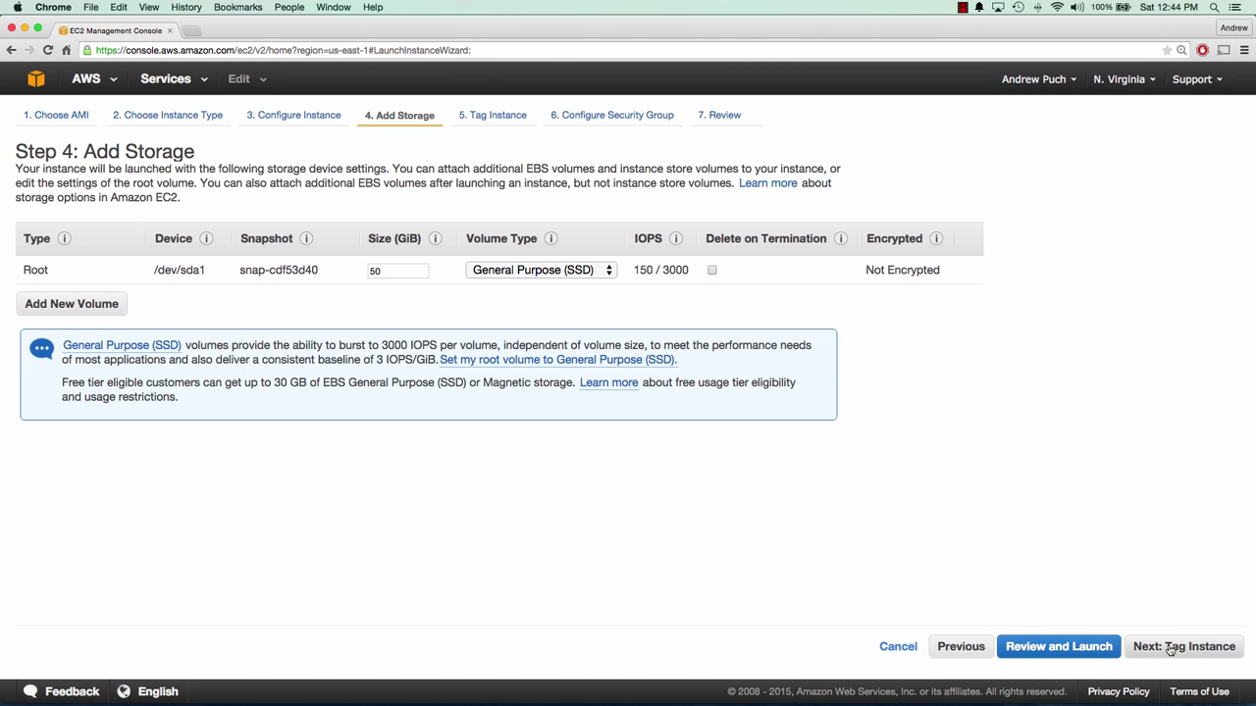

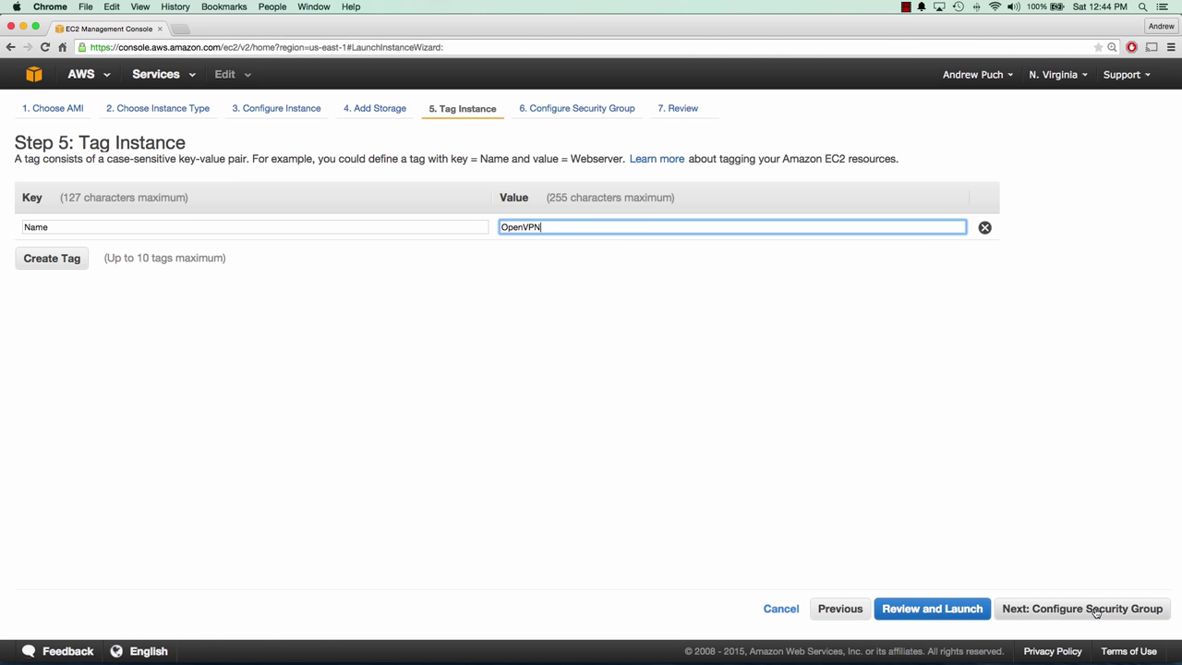

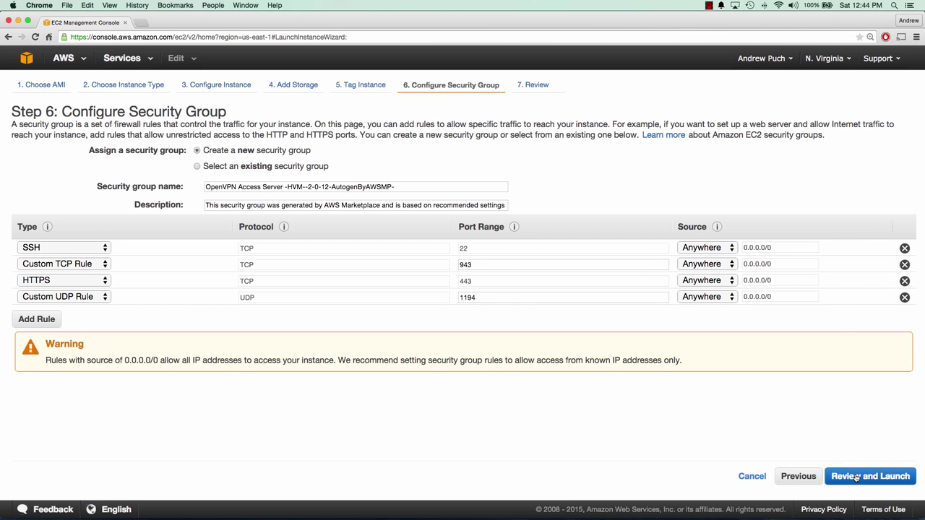

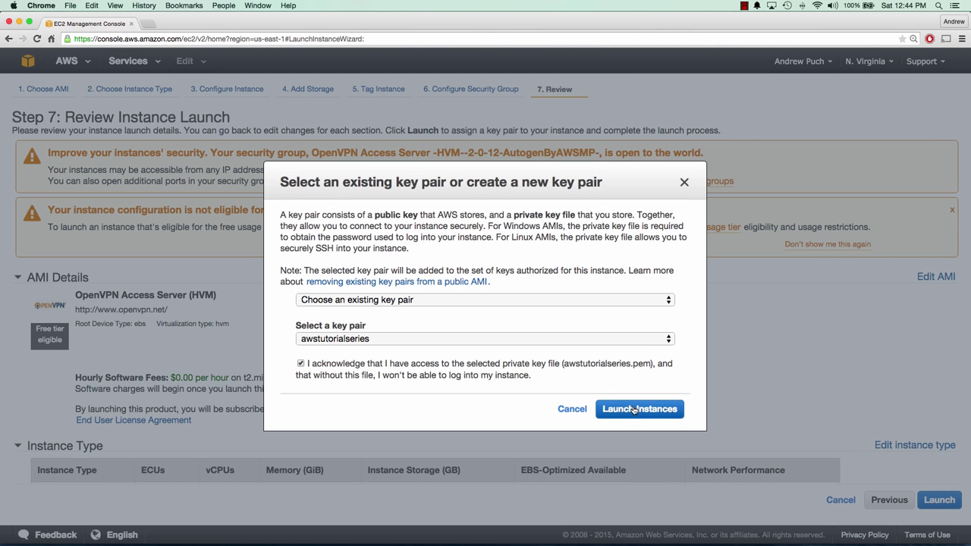

* Create an Elastic IP and attach it with the instance;

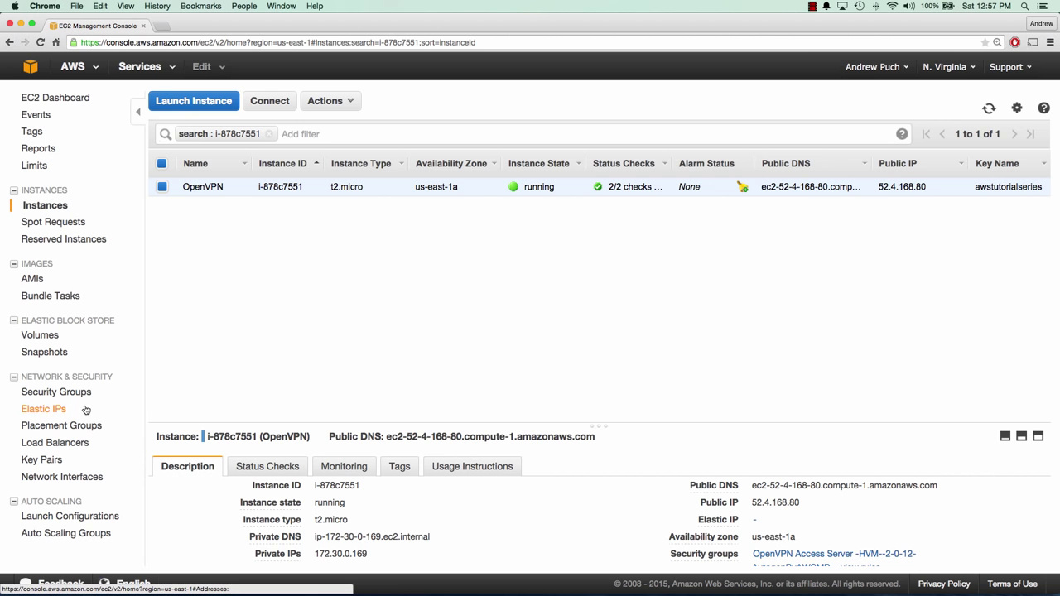

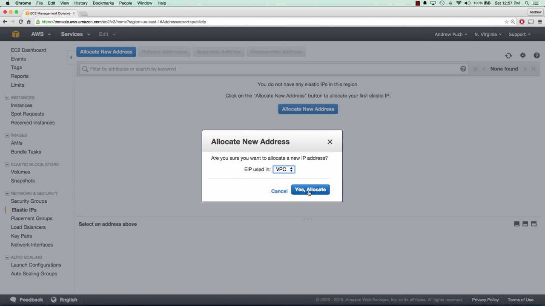

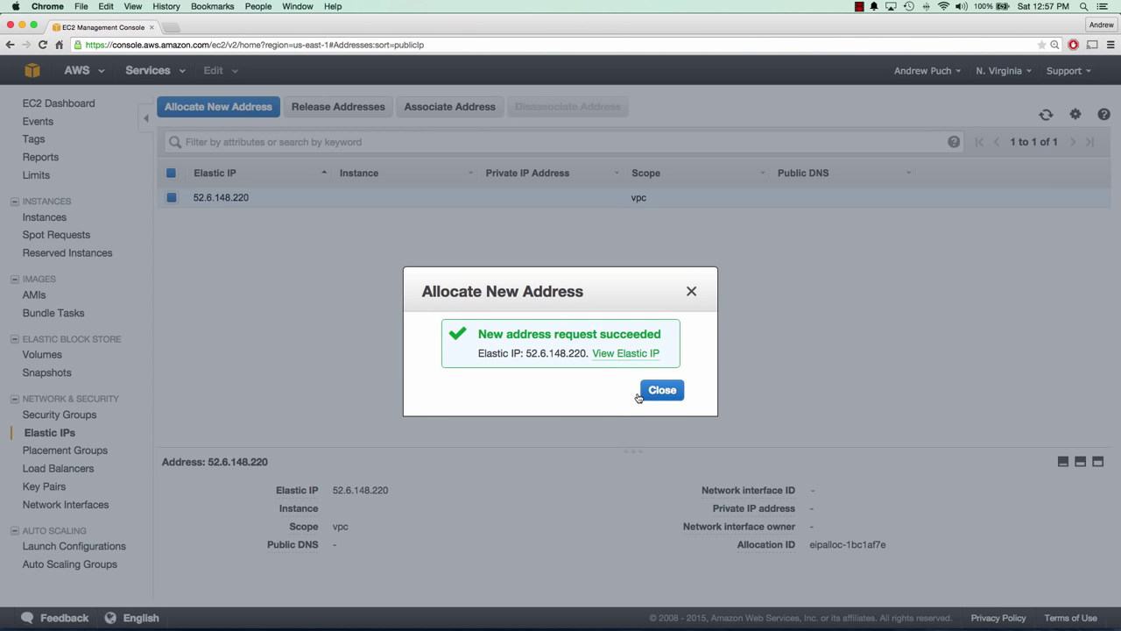

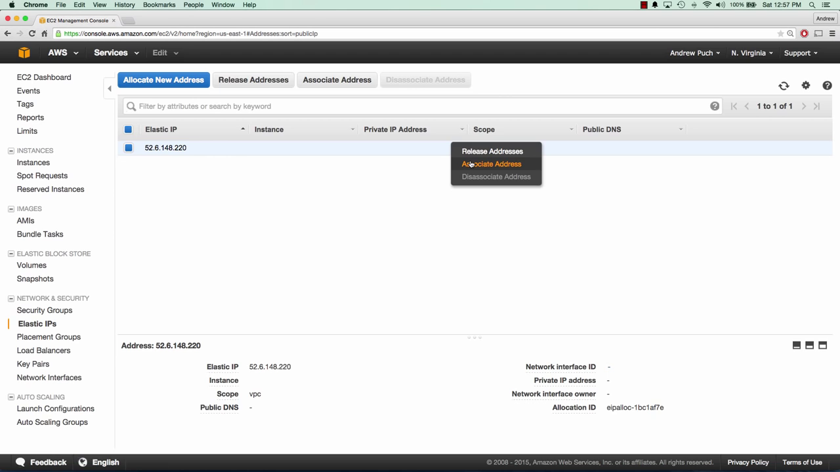

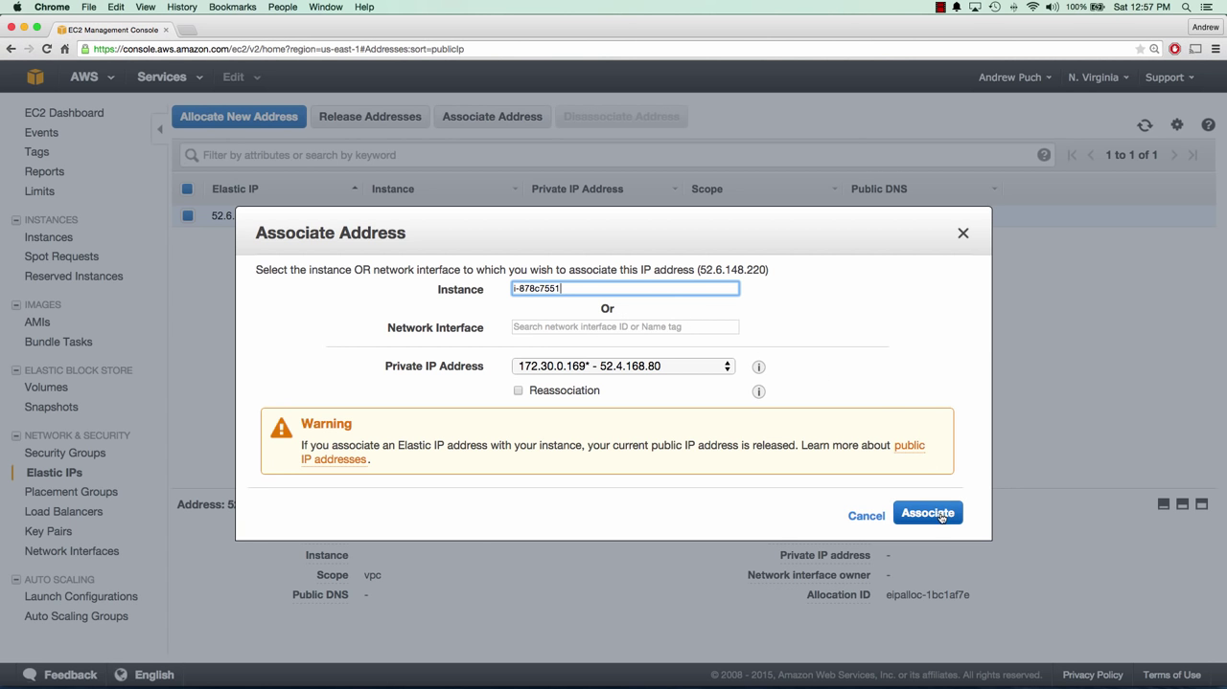

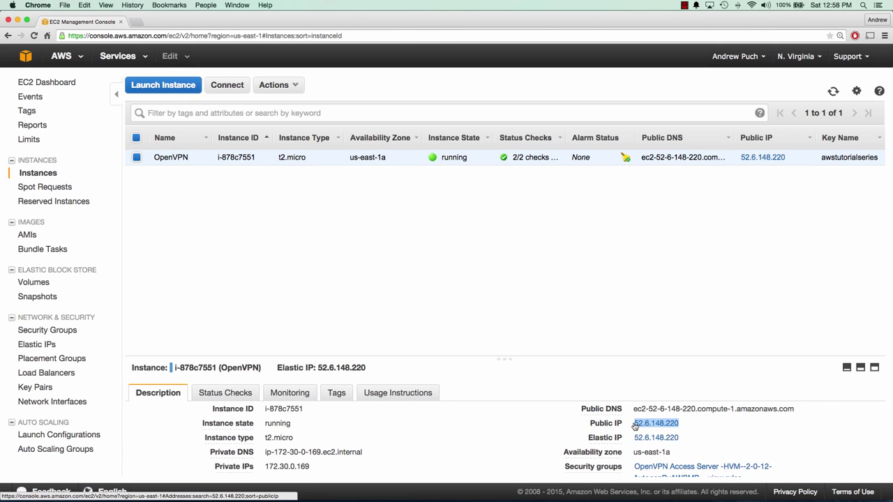

* Establish the SSH Connection through Putty & Complete the further installation by selecting yes & rest values set to default.
* Give host name as openvpnas@elastic ip

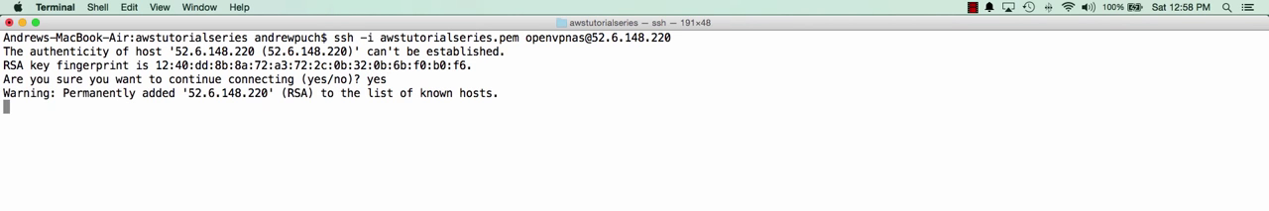

* Change password of the default user(here id& pwd=openvpn)& then shutdown the server.

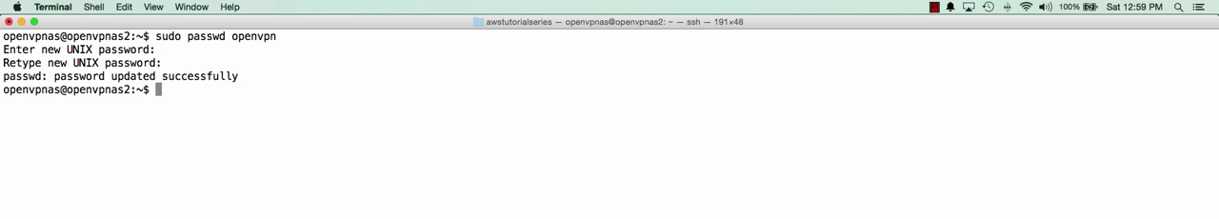

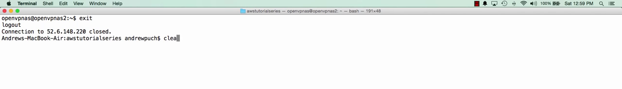

* Loginto the console using public-ip by https://x.x.x.x & download the client openvpn setup & install it, establish the connection.





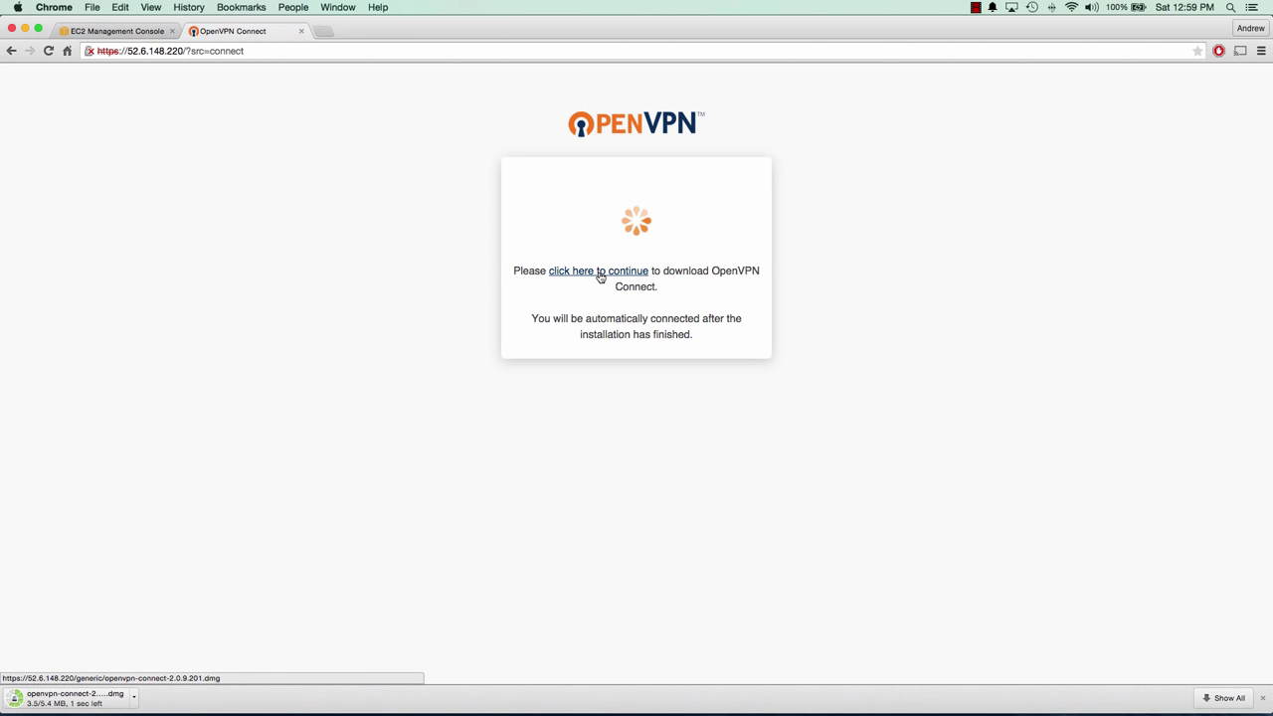

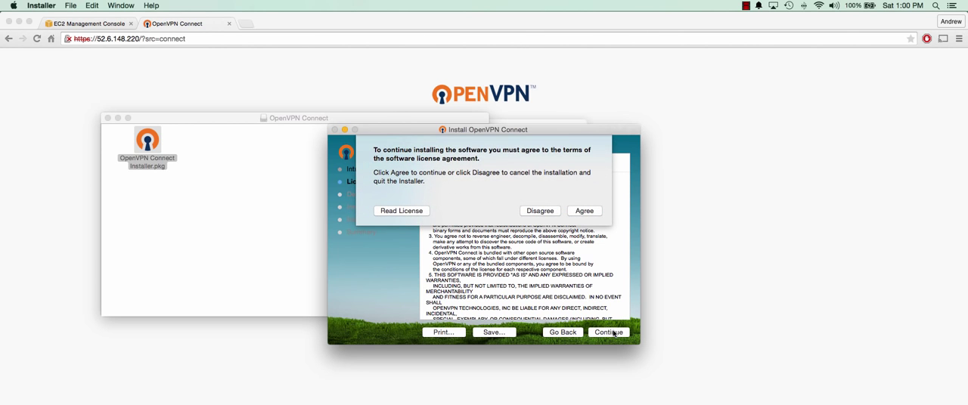

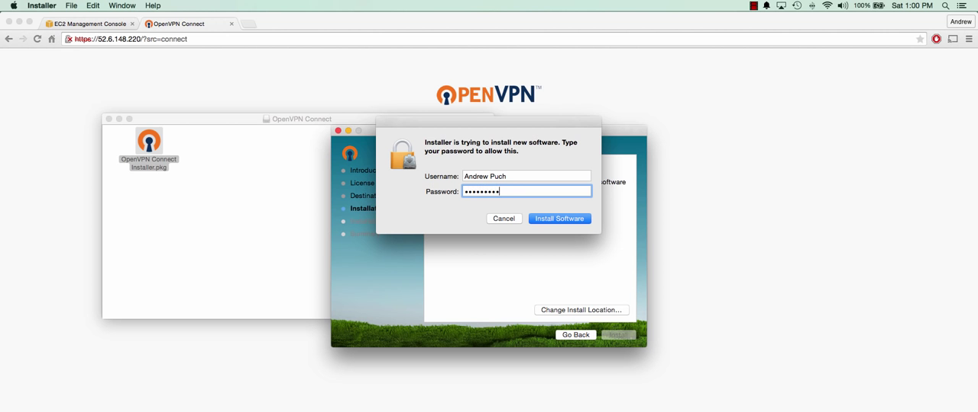

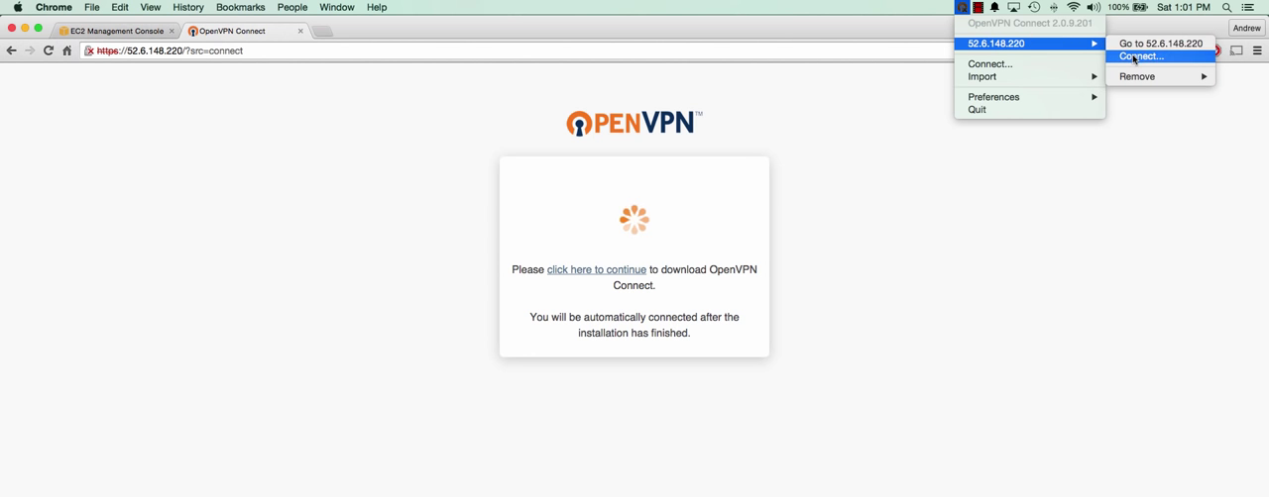

* To perform some security measures login as admin by giving <https://x.x.x.x/admin/>
* To lock down this admin portal only to the internal ip address of the server,in console go to server & n/w settings, there uncheck Admin & Client web server check box, save & update running server. Impact will immediately follows-> since access to the web server through public ip is disabled.



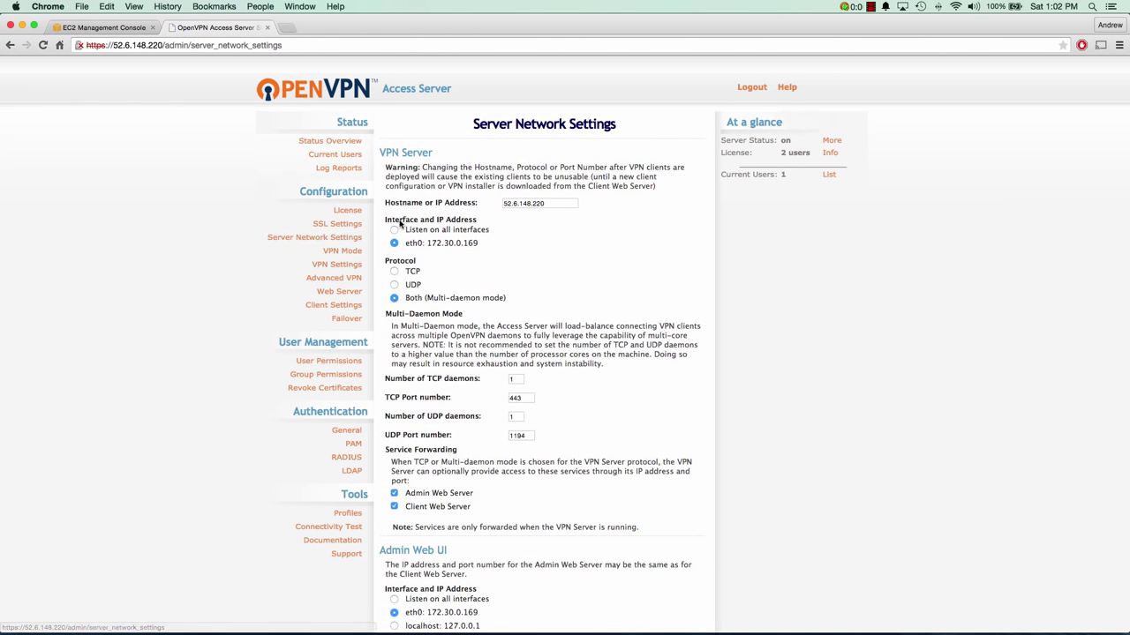

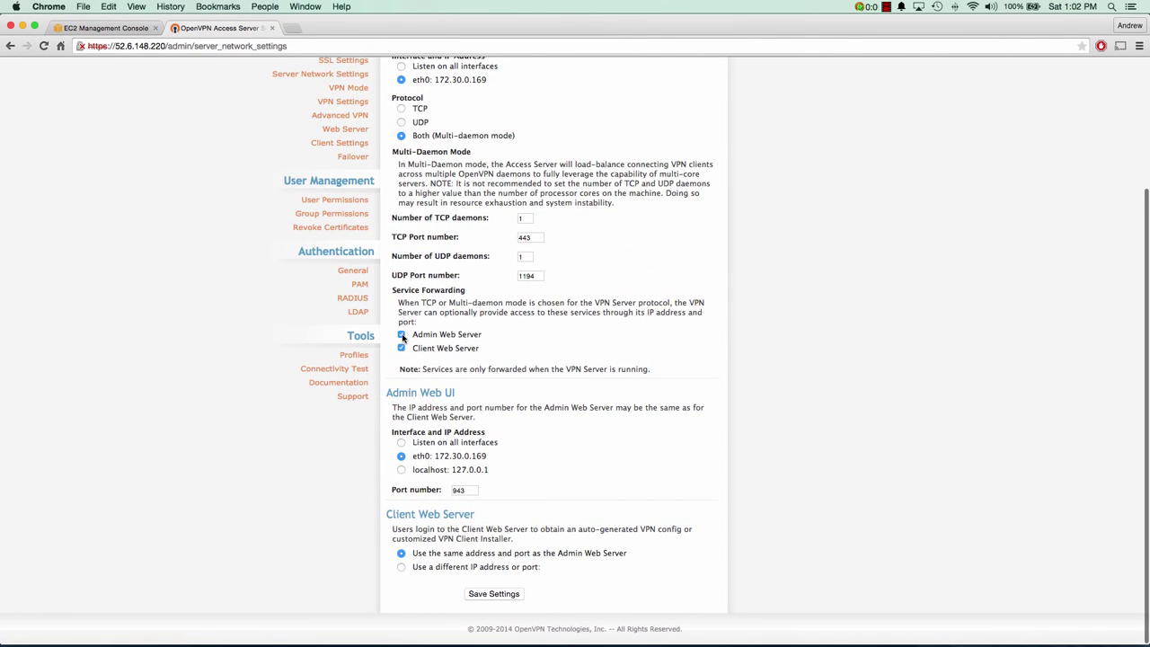

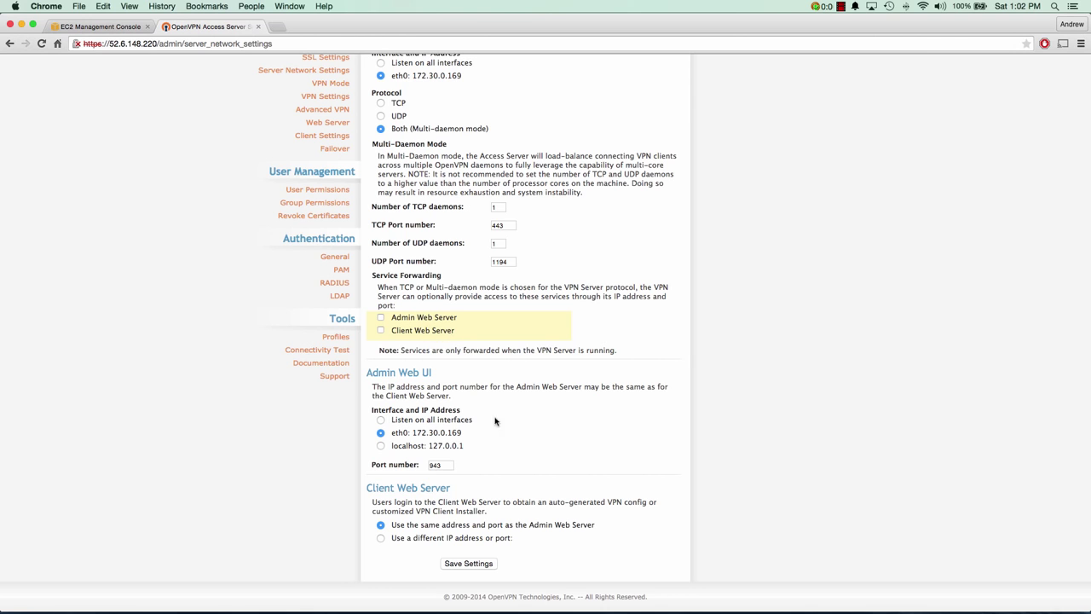

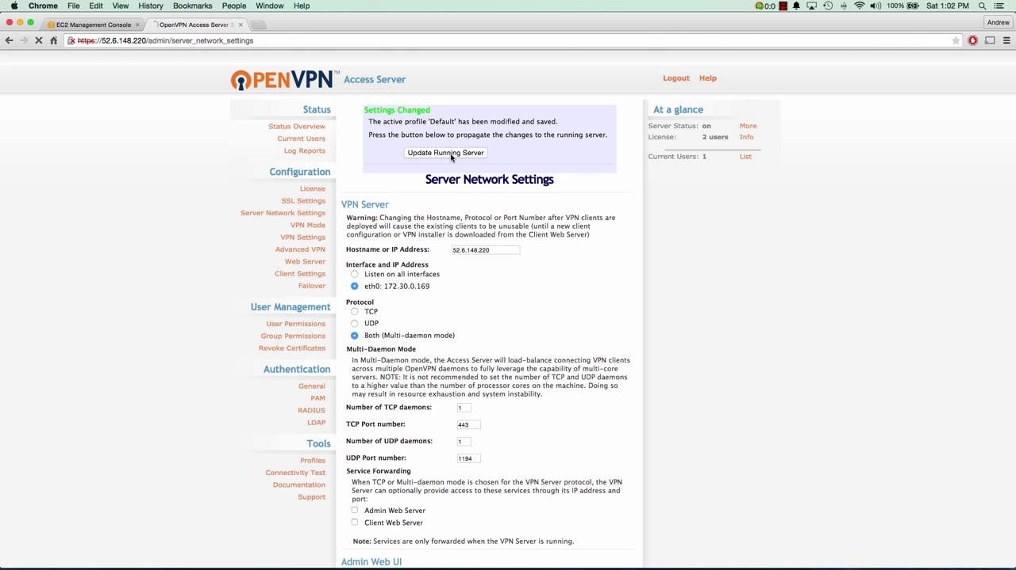

* Access the admin portal through private ip by using port no. 943 like; <https://172.30.0.169:943/admin>

N.B:

|  |  |  |  |
| --- | --- | --- | --- |
| 943 | tcp | silverlight | Port not officially assigned, used by Silverlight Microsoft plugin. Silverlight can add graphics, interactive and multimedia functionality to the Web browser. Port 943 was first used in Silverlight version 2 beta 2 release. |

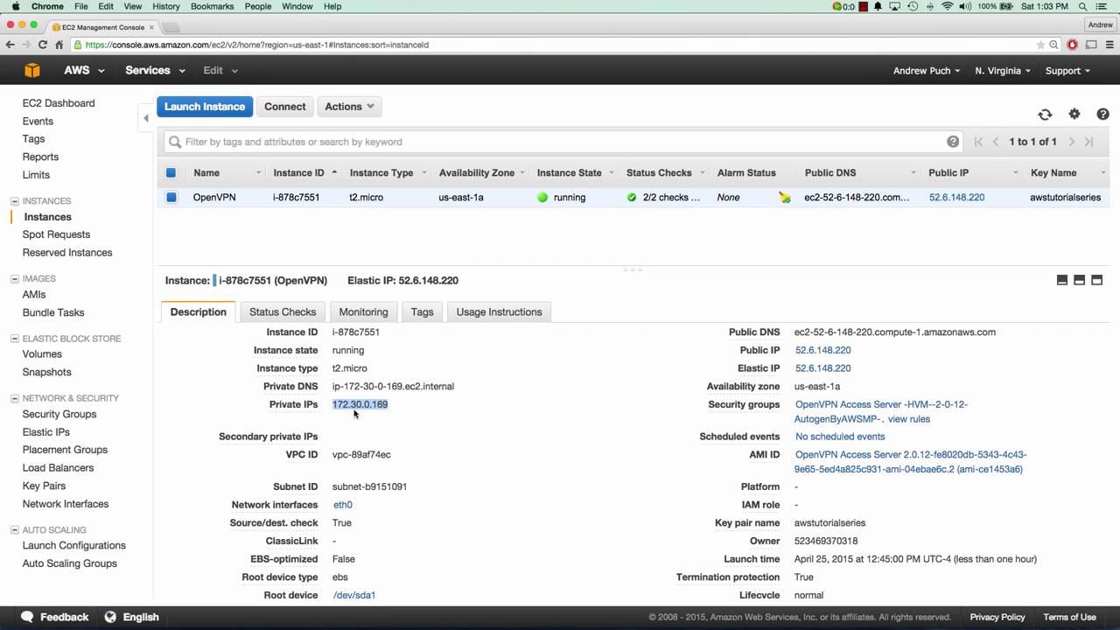



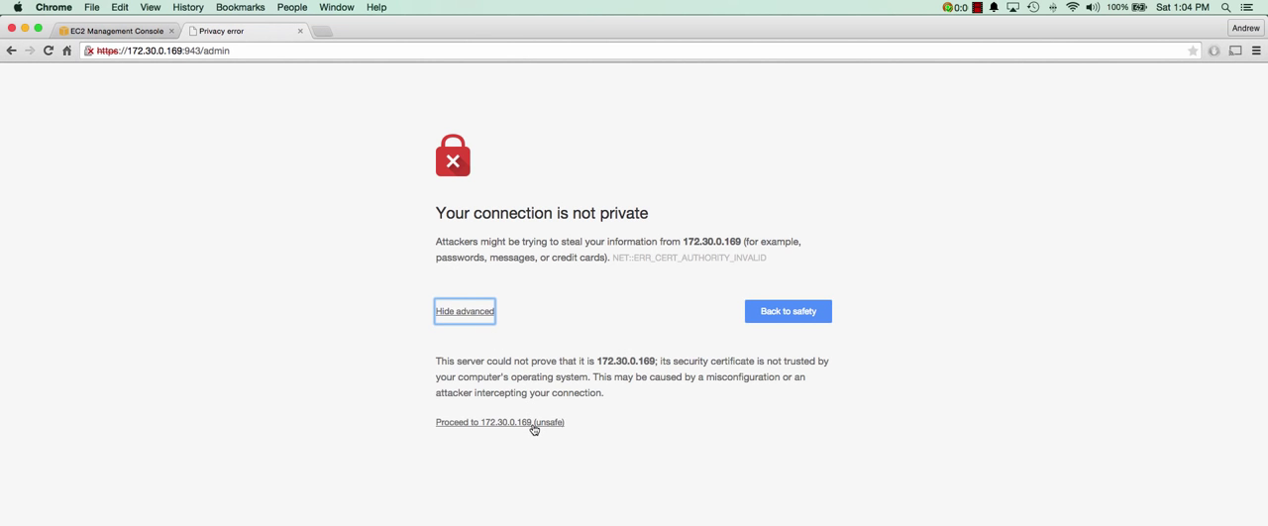

* So we have removed the public access; only through https using public ip we can connect. For the more security measures we can remove the ssh access from the security group.

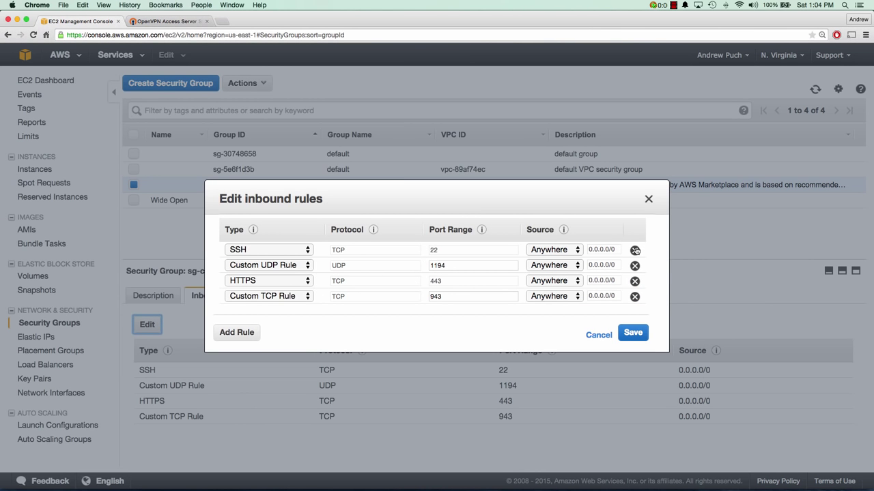

So finally the VPN IS established and we have created the access to private VPN SERVER.